Government corruption leads to higher rates of human trafficking, poverty, crime, mental health declines, and insecure housing. The hundreds of millions of taxpayer dollars that state appointees Lutz, Beydoun, Mikula, Thelen, etc. have inappropriately received (and given) as quid pro quos in just the last couple of years could have been used to combat the very problems that make Michigan the most corrupt (according to the US Attorney) and least transparent state, as well as combat Michigan’s “brain drain” exodus of highly educated/trained workers. When I served clients in the MSU College of Law Housing Clinic eviction diversion program, the difference between homelessness and keeping one’s housing was often smaller than the client’s annual tax bill. Instead of lowering taxes or refunding tax payments to the poor with our recent tax generated budget surplus, Michigan gave appointees millions they neither earned, deserved, needed, or were entitled to.

An SEC cease and desist order civil proceeding is a legal action initiated by the Securities and Exchange Commission (SEC) to demand that a company or individual stop engaging in a specific activity that is deemed to be a violation of securities laws. The order often includes penalties like disgorgement of illegal profits and may be brought against companies and individuals in an administrative hearing before the SEC, essentially telling them to "cease and desist" from the unlawful behavior; it is considered a civil action, not a criminal one.

Under MCL 125.2088c (4)(b) Duties of the MSF fund board, MSF is barred from funding (or reauthorizing funding to) organizations that have been found liable in civil proceeding like the SEC proceeding in which Gentex was found liable. MSF board members may not fund organizations that are found liable “in a civil proceeding, that negatively reflects on the person's business integrity, based on a finding of embezzlement, theft, forgery, bribery, falsification or destruction of records, receiving stolen property, violation of state or federal antitrust statutes.” On February 7, 2023, the SEC found Gentex violated several clauses of the Exchange Act related to falsifying records (13(b) et al), ordered Gentex to pay penalties, and to cease and desist future fraud and record falsification. As stated in my complaint, under ethics laws, Thelen (and his MSF/MEDC ilk) are required to follow the MSF related statutes for distributing funding. Specifically, MCL 15.342 requires officers must use funds under their care according to the statutory procedures.

Thelen was also required by law to recuse himself from voting on Gentex funding. He was required to disclose his conflicts with Gentex as well. He did neither. Additionally, the MSF is prohibited from authorizing funding to Gentex, which is also in violation of the MSF law MCL 125.2088c and ethics laws. Thelen recused and disclosed conflicts not related to Gentex, dozens of other times. When it came to Gentex, Thelen declined to follow the statutory procedures in exercising his MSF board duties at great expense to taxpayers. Thelen’s taxpayer funded attorneys have argued that his vote and lack of recusal don’t count because it was a renewal of funding. The votes and lack of recusal are recorded in the meeting minutes because they are essential to the funding process. The periodic reviews and performance-based renewals exist to stop the very crimes Thelen committed, including funding an ineligible crony organization.

There are 1734 labor unions in Michigan, according to causeiq. The US Bureau of Labor Statistics reported 564,000 union members in Michigan for the year 2023. The governor inexplicably repeatedly turns to the leadership of MRCC for appointees for policy making positions across the state. These union leaders are also repeatedly chosen to receive millions on taxpayer funding despite ample other options for recipients. Mike Barnwell and Tom Lutz, the top two employees of MRCC, have several concurrent policy making appointments between them.

Contrary to Lutz’s BOE complaint answer, Lutz IS part of LEO as an appointee to the Workforce Development Board. The board controls various aspects of workforce development including determining training programs. Additionally, despite Lutz’s answer to the BOE complaint, MEDC does administer his SSBCI funding. Though I have submitted ample evidence and details in the Lutz BOE complaint, I regret being ostensibly too vague about Lutz’s Workforce Development Board Position with LEO. LEO works with MRCC’s MiSchools to Tools grant as is demonstrated by the contract I included in the evidence packet. Lutz’s MRCC employee is the registered lobbyist on TPRG, acting on behalf of MRCC.

Lutz’s organization did not coincidentally get $5 Million worth of funding from both of the boards he is appointed to. The BOE may invite witnesses and investigate MRCC, as it is empowered to. Last year, when the BOE was faced with the question of whether Deb Mikula paid her own salary with MACC grants funds, the board chose to not even ask the question. Of course, Mikula paid herself tens of thousands in taxpayer funded MACC dollars despite not doing ANY art programming.

On behalf of the Michiganders who are incarcerated and accounting for their crimes (which are miniscule compared to the scope of the crimes in my complaint), on behalf of the Michigan taxpayers who cannot make ends meet, for those who do not know all the ways their government is stealing from them, please investigate this case thoroughly. The overwhelming majority of Michigan ethics complaints are dismissed because the process is esoteric and requires significant legal knowledge that the general public does not possess. One such recent dismissal was the SEIU/Jennifer Root complaint. Since that dismissal, SEIU is poised to receive millions in home health worker employer funding from Medicaid. Even once a BOE complaint passes muster, the system does much to protect potential culprits including providing them with attorneys. The public deserves a robust investigation (not led by a single taxpayer). The BOE process can be a low-stakes means to curb Michigan’s corruption. The cruelty of Michigan’s persistent cronyism is profound, preventable, and up to the BOE to discourage.

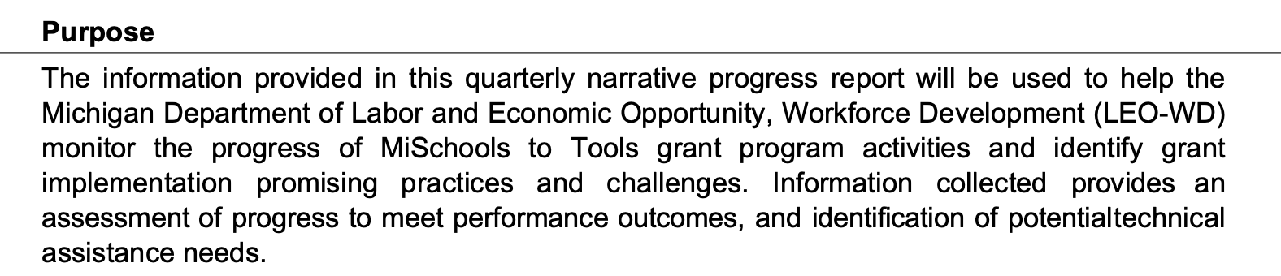



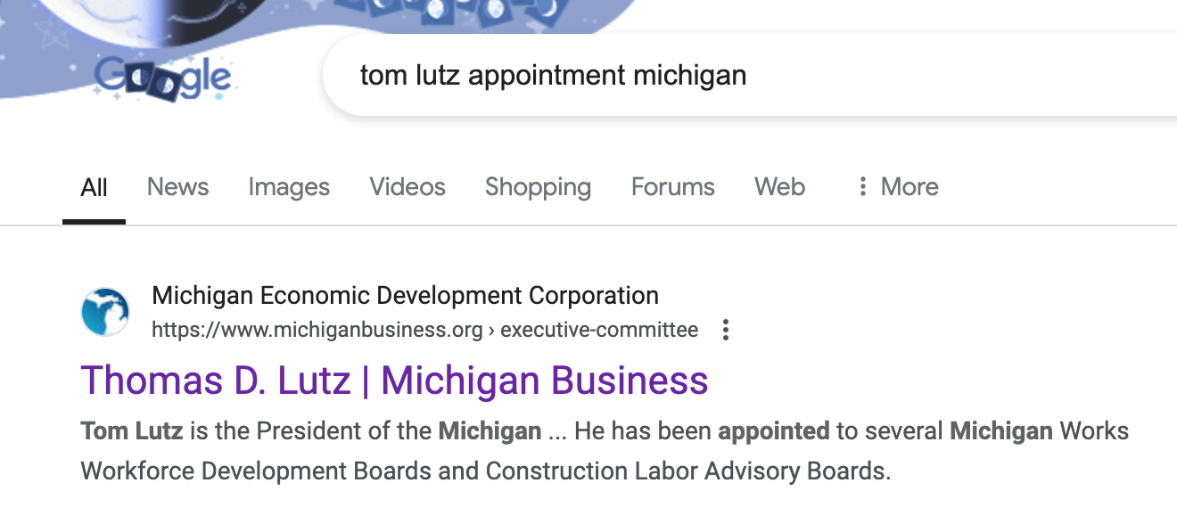

https://pmc.ncbi.nlm.nih.gov/articles/PMC6014157/ https://pmc.ncbi.nlm.nih.gov/articles/PMC8254936/ https://pmc.ncbi.nlm.nih.gov/articles/PMC6475861/ https://pmc.ncbi.nlm.nih.gov/articles/PMC8356278/
https://www.metrotimes.com/news/us-attorney-michigan-is-the-nations-most-corrupt-state-21817066 https://www.lansingstatejournal.com/story/opinion/contributors/viewpoints/2023/10/22/michigan-foia-transparency-legislature-governor-stall/71232546007/
https://www.sec.gov/files/litigation/admin/2023/34-96819.pdf
https://www.causeiq.com/directory/unions-list/michigan-state/#:~:text=Michigan%20unions-,Michigan%20unions,1%2C739labor%20unions%20in%20Michigan.
https://www.bls.gov/regions/midwest/news-release/unionmembership_michigan.htm#:~:text=Michigan%20had%20564%2C000%20union%20members%20in%202023.
https://www.michigan.gov/whitmer/news/press-releases/2024/09/10/governor-whitmer-makes-appointments-to-boards-and-commissions https://www.michigan.gov/whitmer/news/press-releases/2020/08/28/governor-whitmer-makes-appointments-to-boards-and-commissions121819-1-5
https://www.michigan.gov/leo/bureaus-agencies/wd https://www.michigan.gov/whitmer/news/press-releases/2024/09/26/governor-whitmer-makes-appointments-to-boards-and-commissions
https://www.michigan.gov/whitmer/news/state-orders-and-directives/2020/05/29/executive-order-2020-107
https://www.michiganbusiness.org/4aa8d6/globalassets/documents/msf-board/msf-board-packets/october-2024-msf-board-packet---final.pdf
https://www.steveharrypublicpolicy.com/essaysLTE/Essay20241111.html
https://www.michiganbusinessnetwork.com/blog/medc-lenders-may-now-apply-for-small-business-loan-enhancement-support

